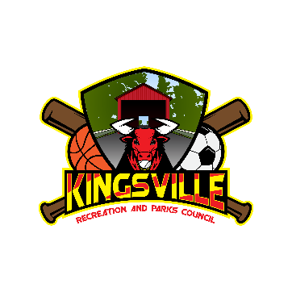

Kingsville Recreation and Parks Scholarship Award
11530 Philadelphia Road White Marsh, Maryland 21162 410-887-5194

The Kingsville Recreation and Parks Council will award four (4), Five Hundred Dollar Scholarships ($500) to qualified applicants. Scholarship will be presented in one payment.

Scholarships will be given to student based on his/her involvement in Kingsville Recreation Council, community involvement, extra- curricular activities, high school transcripts, and parent involvement as a past/present volunteer of the Kingsville Recreation Council who have volunteered their services to better the Council and its programs.

Scholarship requirements:
with involvement at Kingsville Recreation Council.

May 6, 2024

Paul Muller 7935 Bradshaw Road
Upper Falls, MD 21156

- Name in full
First Middle Last

- Address

- Home Telephone number

- High School

Middle School Elementary School

- List any personal involvement in the Kingsville Recreation Council:

- List any parent involvement in the Kingsville Recreation Council- Leadership positions held and the year held:

- List community activities (Church, School, Scouts) and extracurricular activities you have participated in:

Kingsville Recreation Council Scholarship Application

- List any work experience you have had:

- Are you planning to work while attending college? Yes No

If Yes, Full-time Part-time

- Where have you applied for admission to college, trade or technical school:

- At which college(s) have you been accepted:

- Which college are you planning to attend:

- College Major: _

- Do you plan to board: _

- Are you a recipient of any other Scholarship Awards:

- What, in your opinion, are special facts which you like the committee to consider in connection with your application (use additional paper if necessary):

- Why do you feel you should be selected for this scholarship (use additional paper if necessary):

If I am a recipient of a Kingsville Recreation Council Scholarship Award, I understand that the scholarship is to be used only towards my college, trade or technical school education and must be used by June 2025.

APPLICANT’S SIGNATURE DATE

